Elkhart and St Joseph Counties Head Start Consortium
This institution is an equal opportunity provider
FALL FAMILY
FESTIVAL
Come and make memories at our
Head Start Fall Family Festival.

Performances by your child’s classroom
Date: November 21, 2019 Elkhart County Location : Jimtown North Time: 5:00 pm
Adress: 30046 CR-16-W, Elkhart , In 46516
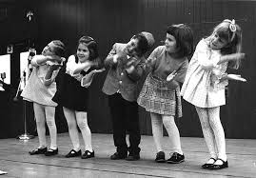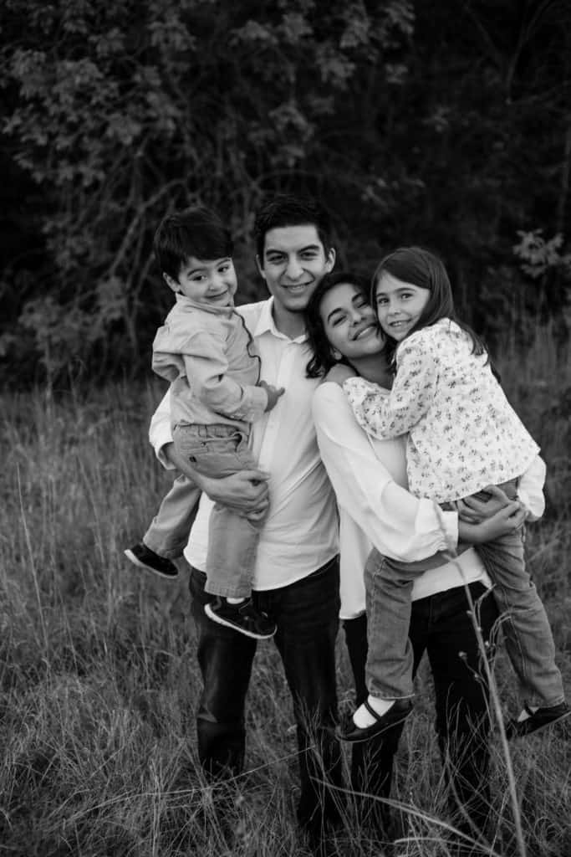Creating connections building bridges with your community

Prizes

FOOD

* Learn together as family
Health and Wellness
Family Development
Fatherhood/Parenting

