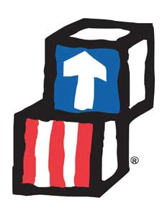

**Book List**

Klondike do not eat the cupcakes! By Amanda Driscoll

In the middle of Fall By Kevin Henkes

The Problem with Pumpkins By Barney Saltzberg

**Parent Engagement**

If you have not done so yet please complete Physical/Dental

Oct 5th -10th Salvation Army Christmas Assistance Program sign up

Kroc Center Western Ave 9:00-11:30 and 12:30-3:00

Policy Council announcement coming soon

Make a daily routine with your child.

Head Start Classroom: Studebaker Room # 4

Elkhart and St. Joseph Counties Head Start Consortium

Mrs. Wells/ Mrs. Nina October News letter

**Monthly Nutritional Activities**

**October 5th**

**Simon Says**

**October 12th**

**Move your Body**

**October 19th**

**Circle your Favorites**

**Nursery Rhyme/Song**

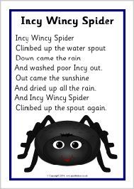

**Social/Emotional Tips**

Encouragement focuses us on the behaviors we want so children learn that we value helpfulness, become aware of their own helpful acts and become more willing to act in helpful ways in the future.

Conscious Discipline

**Monthly News and Updates**

**No Virtual Learning**

**October 9th Teacher record day**

**October 12th,13th Fall Break**

**October 15th, 16th P/T Conference**

**We are now in another Month of School. Our School year has started off a little different this year. The past month we have worked on different things during our virtual learning. We started off getting them familiar with us and the safety habits of riding the bus with Safety Sam. We are getting through the changes and getting ready to start the year face to face. We will continue talking about the Safety rules for the bur. We will continue working on Math with our numbers and organizing and sorting. We will continue working on Language and literacy reading stories and recognizing letters and their sounds.**

**Please remember to send a picture of your child doing the activity of the Home activity. Materials will be mailed instead of picked up weekly.**

**I would also like to Thank you for participating and working with your child during the Virtual Learning, Parent engagement is very important.**

**Thank you**

**Mrs. Wells/Mrs. Nina**

**Class # 574 393-6259**

**FACS# 574 261-1444 Mrs. Ahlania**

**This institution is equal opportunity**

**This institution is an equal opportunity provider and employer**