How to Manually Update Windows 10

1. Select the Start (Windows) button from the bottom-left corner of your laptop screen.
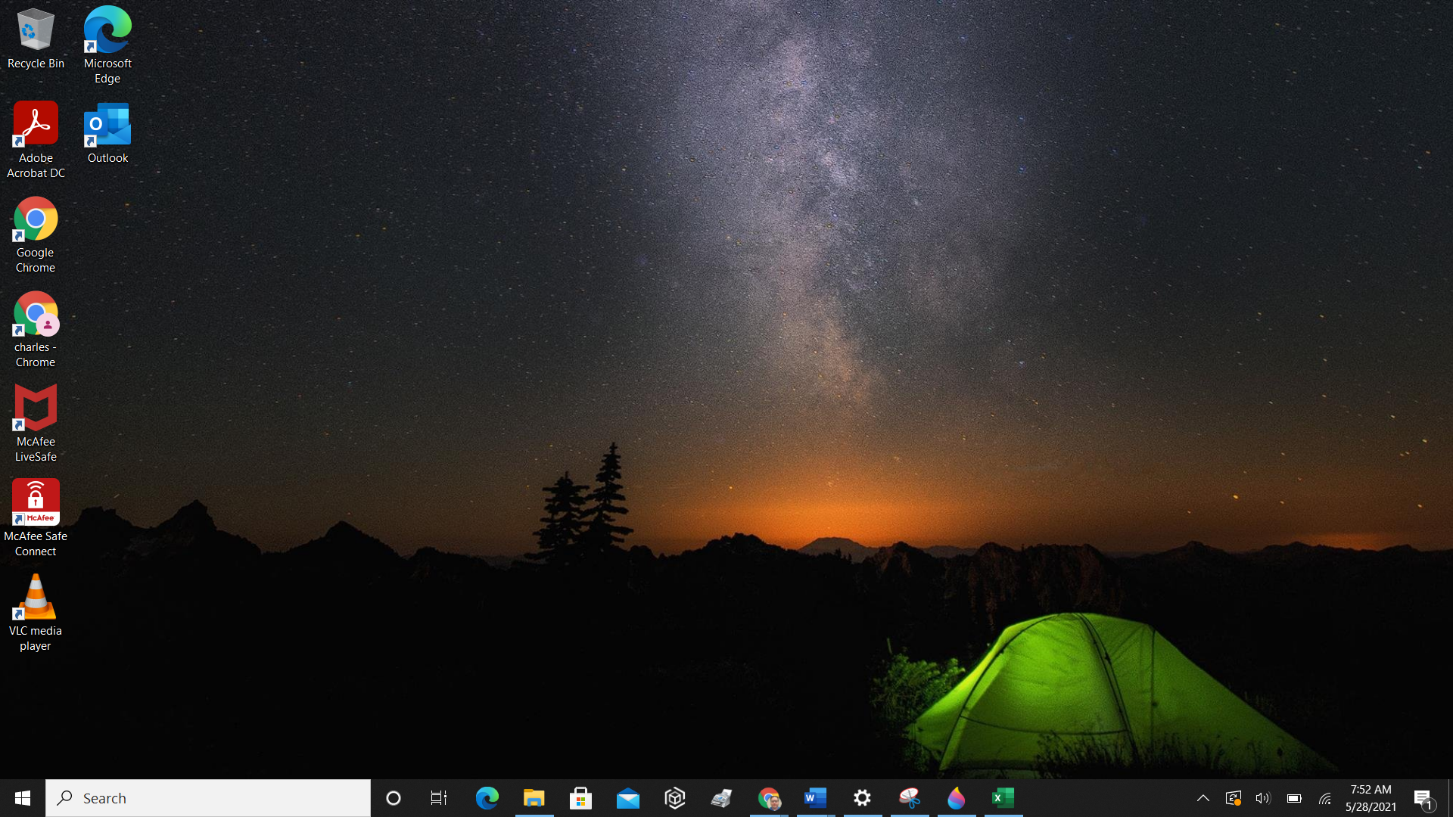
2. Go to settings (gear icon).
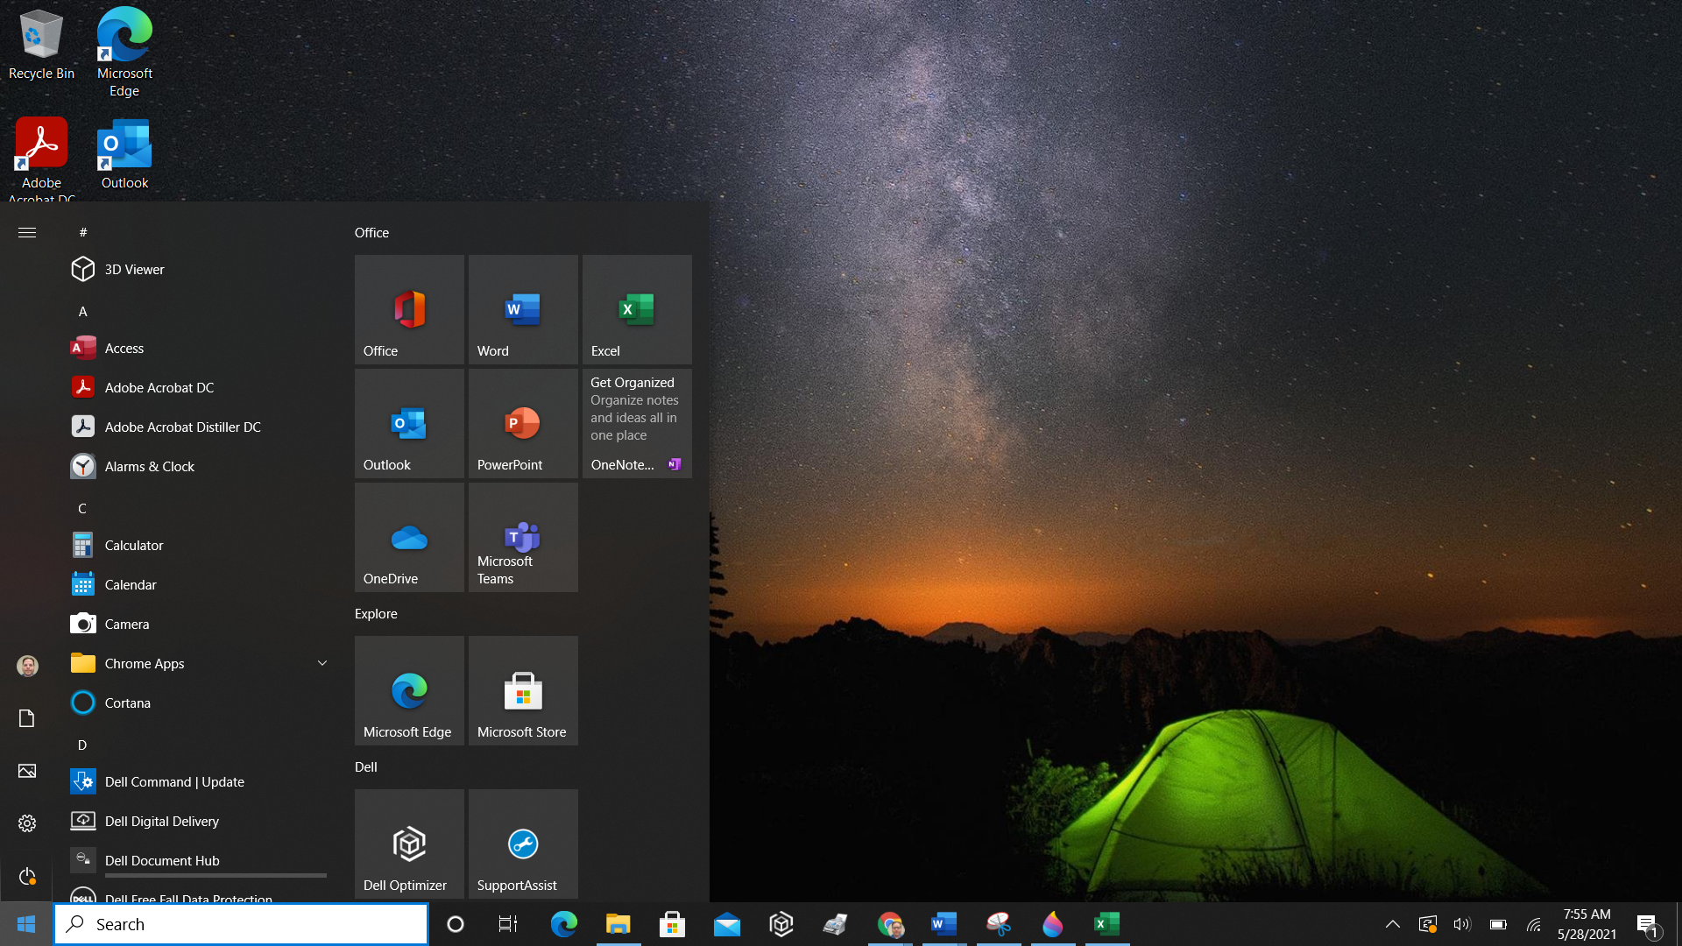
3. Select the Update & Security icon
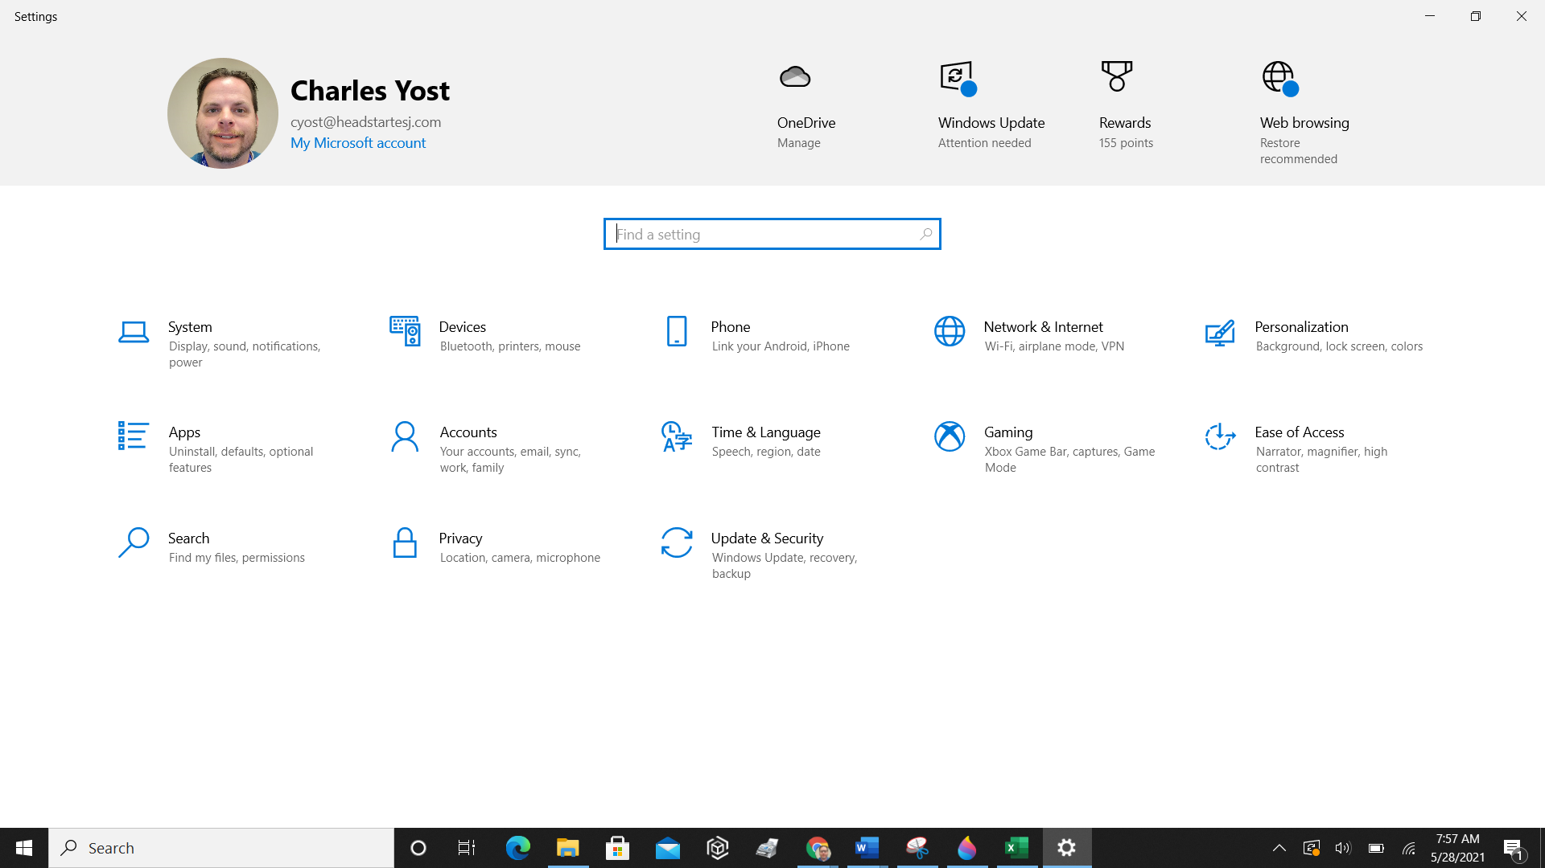
4. Choose the Windows Update tab in the left sidebar (circular arrows)
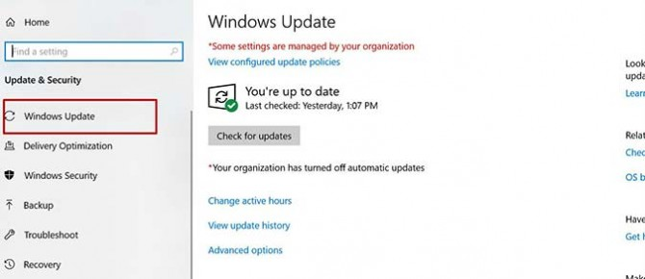
5. Click the Check for updates button. If there is an available update, it will begin downloading automatically.
Also, make sure to install all optional updates like drivers and other updates from the manufacture. If you have any questions, please let Charles Yost know by submitting a Help Desk ticket through Zoho Desk on the Dashboard.
To finish the update, you will need to restart your laptop, but you can do this later if need to save anything that you are working on. Updating is pretty straightforward — just follow the above, simple instructions. (Note, your system will not be equipped with the latest updates until it has been restarted.)

