How to Transfer Photos from Kindle Fire

to Computer

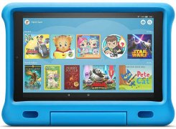
If you’ve taken numerous photos and videos on your Fire 7 (9th Generation) Kids Edition, these Kindle tips can be helpful for you to transfer your files from Fire 7 (9th Generation) Kids Edition to your computer. Let’s go-ahead to the computer and get started.
Before we get started, we’re going to need a couple of different items.
- One thing is your Fire 7 (9th Generation) Kids Edition tablet that you have.
- The other is the cable that comes with your tablet. Just because some third-party USB cables may not actually have the ability to transmit data.

Transfer Files from Kindle Fire via USB
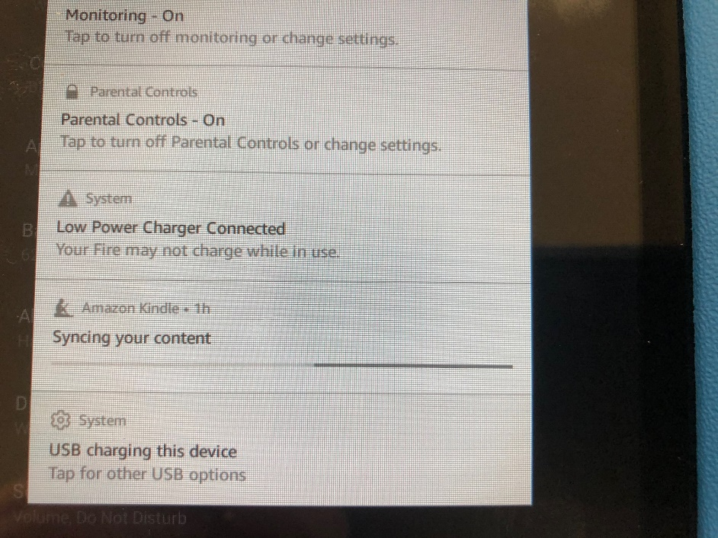

Step 1. Plug the USB cable into the Fire tablet
Once you’ve connected your Fire 7 tablet to the computer with the USB cable, you may get a little tone that indicates that it has connected. Swipe down from the top of the screen and that will allow you to select “USB charging this device”.

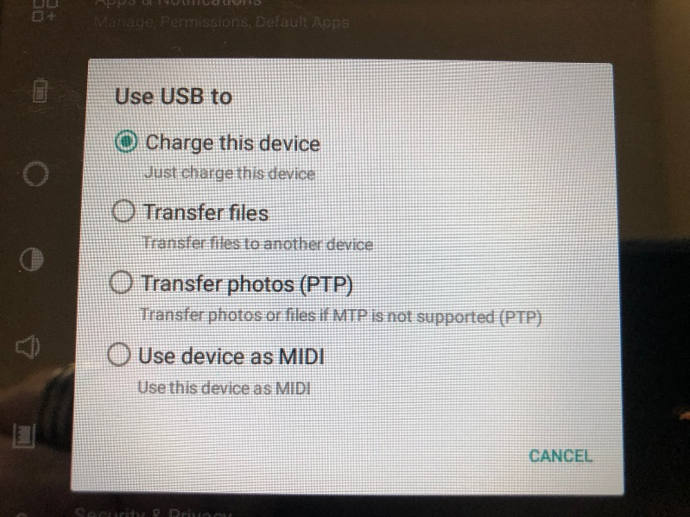
Next, select “Transfer files” or “Transfer photos (PTP)”.

You should see something similar to the picture below:
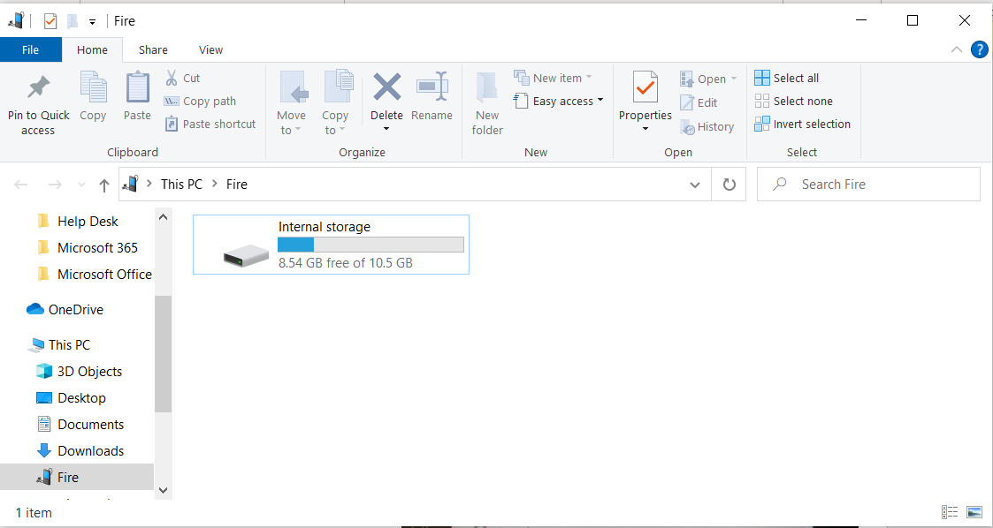
Step 2. Create a folder to store your photos
Go to the further step, create a folder that we’re going to use later to actually back up the files. You can put the file anywhere you want. If you have a specific location where you store your photos or if you use the default pictures folder of the computer.
To create a folder, right-click in “Documents” folder, hover down “New” and then left-click on Folder and name the folder whatever you want. Once you have that, just go ahead and hit enter and it will finalize that edit. We’ll come back to this folder in just a few moments.
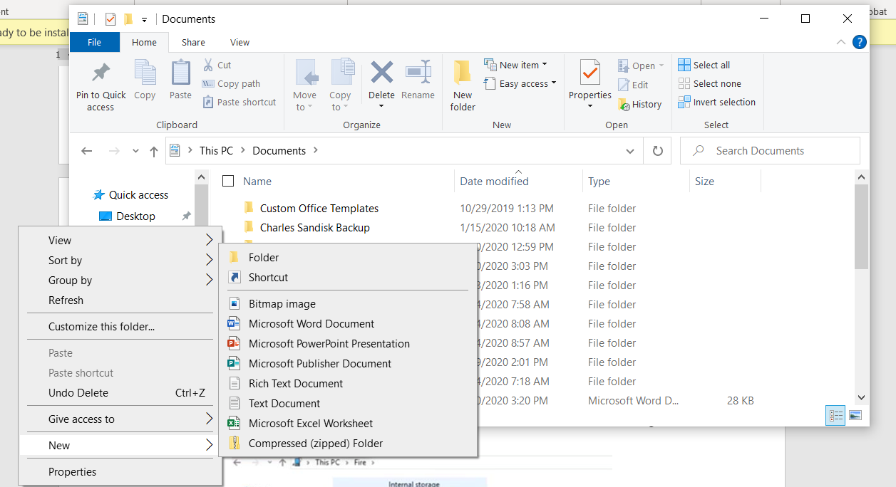
Step 3. Transfer pictures from Kindle Fire to PC
What we’re going to do now is the bottom left hand of the screen, you’re going to notice you may have a file explorer window, left click on that and you’ll notice that the Fire device will show up under devices and drives. Double left-click on Fire, you will see the location for storage of your Fire tablet.
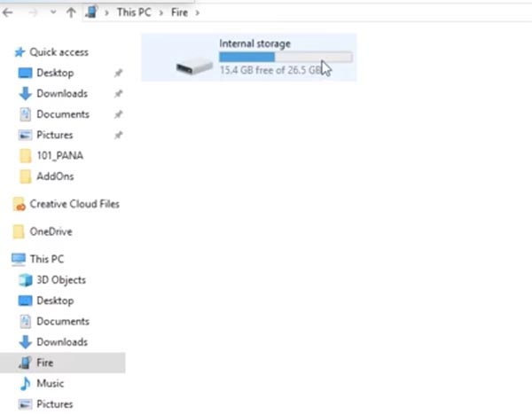

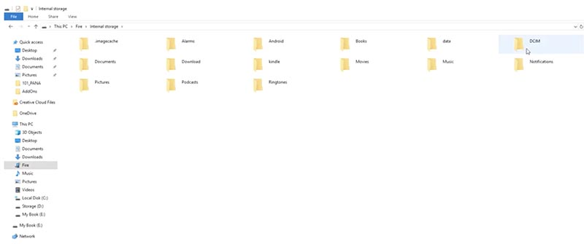
- Double left-click on internal storage, and we’re going to look for a folder that says “DCIM”, which stands for Digital Camera Image.

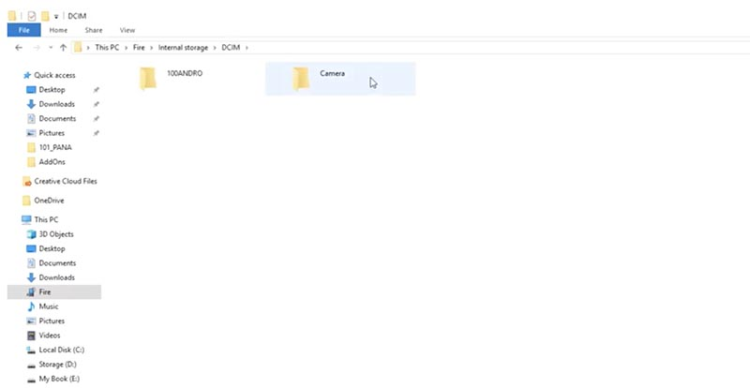
- Double left-click it and then double left-click “Camera”.
- And then you’ll see the pictures in the folder.
- Then, you can highlight by left clicking and dragging, and that will select them allowing us to copy those over. Or you can hit Ctrl+A to select and backup all of those photos to the computer.
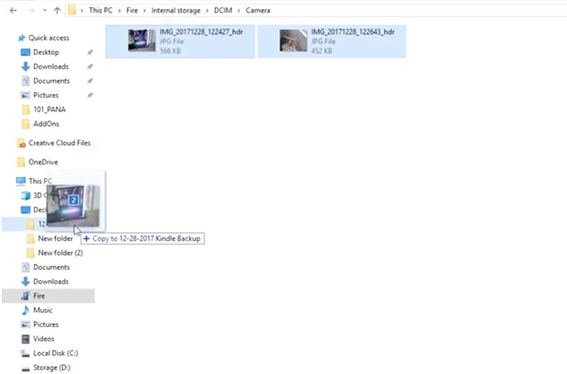
- Navigate on the desktop and find out where we put that folder. If you look on the left of the desktop, you can find the Kindle backup folder you’ve just now created.
- Then, drag the selected images to the Kindle backup folder, by holding left-click.
- You may see a progress bar that comes across the screen.
- Double check and make sure that those photos have actually backed up to the folder.

