Step 1.
Go to Head Start’s Dashboard and click on the “Outlook” Icon like the picture shown below:
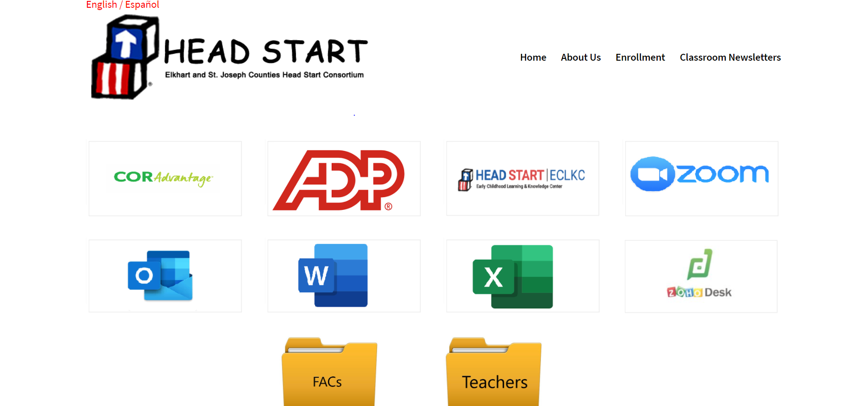
Step 2.
After you click on the “Outlook” Icon, then you should see something that looks like the picture below and this is where you will enter your email/username. The email/username will look something like this test@headstartesj.com:

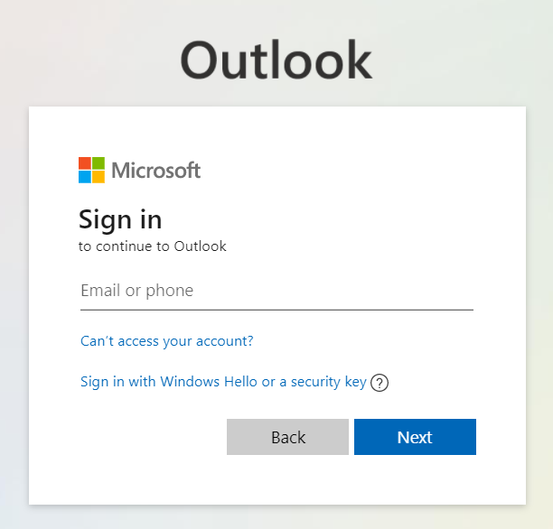
Step 3.
Next, you will type in the temporary password that you were provided with. You will not need to remember the temporary password.
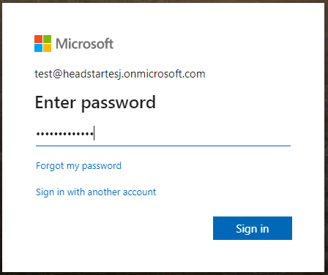
Step 4.
Once you have entered your temporary password, you will then be asked to create a new password. Note: To ensure your password meets Head Start security requirements, please follow the below directions for creating your password:
- Has 12 Characters, Minimum: You need to choose a password that is long enough. Passwords should be a minimum of 12 to 14 characters in length.
- Includes Numbers, Symbols, Capital Letters, and Lower-Case Letters: Use a mix of different types of characters to make the password harder to crack.
- Is not a Dictionary Word or Combination of Dictionary Words: Stay away from obvious dictionary words and combinations of dictionary words. Any word on its own is bad. Any combination of a few words. For example, “house” is not a recommended part to be used in a password. “Red house” is also not recommended.
- Does not Rely on Obvious Substitutions: Do not use common substitutions, either — for example, “H0use” isn’t strong because you’ve replaced an o with a 0.

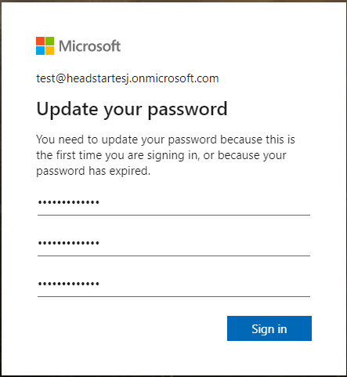
Step 5.
After you choose Sign in, you'll be prompted for more information.
Choose Next.
Select your verification method and then follow the prompts on the page. You can also watch the video to learn more.
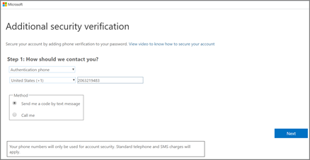
After you test your additional verification method, choose Next.
Once you complete the instructions to specify your additional verification method, the next time you sign into Microsoft 365, you'll be prompted to provide the additional verification information or action, such as typing the verification code that is sent to you by text message.
To have a new code sent to you via text, refresh your browser tab.
Final Step.
Once you have created your new password, you should see the below screen when logging into your Office 365 account. If you do not or having issues with logging in, please let the IT Help Desk know.

